Student Assessment Submission and Declaration
When submitting evidence for assessment, each student must sign a declaration confirming that the work is their own.
Student name: Adel Shurab /21023153 |  | Assessor name:
Issue date: | Submission date: |  | Submitted on:
Programme:

Unit:
Assignment number and title: Assignment 2- Implementing AI Systems
TITLE:CHAT BOTS FOR SOLVE PROPLEM IN ASAC
Adel.M.Shurab
Ai Student
ABSTRACT:
When Corona (Covid-19) came and Jordan became in a state of emergency, which forced most universities and colleges to teach remotely, here the universities faced problems communicating with students due to their large number and they were not ready for such problems. The problem and helps to answer the largest number of students at one time Chat bots is very popular right now and it is attracting speed as a Computer communication application software responds as intelligently as a human. This type of software is called a chat bots this paper deals with the design and implementation of a chat bots system for universities and the intended university is ASAC and the chat bots that we will introduce is a conversational Chat bots.

Introduction:
Chat bots: it's a computer program that simulates a natural human conversation, people communicate with a bots via chatting or voice, as they talk to someone real We have three types of chat bots: 1-Rules-Based Chat bots2-AI Chat bots. 3- Live Chat. [1]
I will explain these types here: How does each type works?
Rules-Based Chat bots: It conducts pre-determined activities based on "playbooks," which you build up on the back end of the user interface, similar to a virtual assistant. It can work on clicks, such as choosing "Yes" or "No," or by recognizing a keyword or collection of phrases. [1]
AI Chat bots: It uses artificial intelligence & natural language processing (NLP), to understand sentences structure, then do the process for these sentences and progressively get better at answering the question which user asks, first thing that AI bots understand is what is your question? then they give you an answer which they think is the correct answer based on existing data, with overtime and, by monitoring correct and erroneous responses, the machine improves its grasp of what the 'proper' response is. [1]
Live Chat: t works as a window to your team for your client, this software has a There's some routing functionality for assigning real-time discussions, but it's mostly straightforward. so, When someone wants to communicate and someone from your team is available, live chat links them with someone from your team who can help them with their problem. [1]
The latest accomplishments in creating chat bots: 1-the ease with grammar and creativity. 2-Fluid, natural-like speech-enabled by text mining. 3- Image recognition. 4- Context understanding. [1]
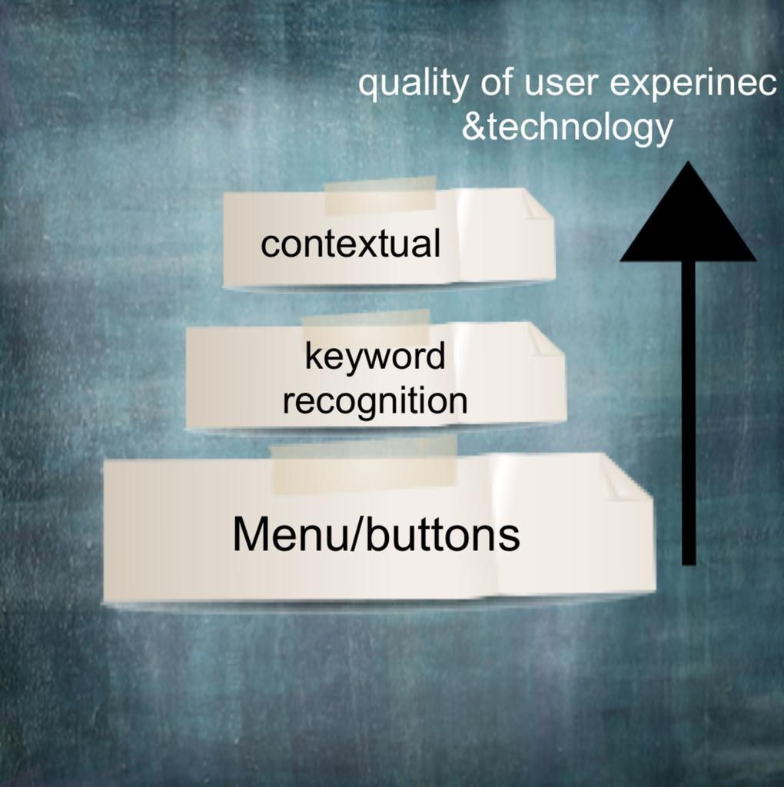
Figure 1 this image was made for illustration
bots are expected to be used more than now in companies, so these bots will help companies gain market share and will be a huge investment in customer experience in the following years: Chat bots with education field: The future of chat bots with education will be full, as education, in my view, is the best field for the development of chat bots in it. In the future, chat bots will be able to answer students’ questions at the same time as this will save more time for the teacher to follow the educational material more, or even the robot will be Is the teacher who knows? the system that we will focus on, which is the educational system, and the bots that we will focus on is contextual chat bots This bots is classified as AI chat bots The use of chat bots applications has become very popular, as it is of paramount importance to have an external student facing chat bots along with an internal bots to serve the employees. My own chat bots for ASAC and this is a nice step to develop even if it is a simple thing in education, and this will aim to reduce errors and alleviate the staff at the university and will aim to serve the largest possible number of students at the university and it can be used in schools by creating a special application for each school and downloading It has the entire school system so that the bots is fully aware of everything related to students, teachers and the entire school. As for universities, it will be added to the university’s website or if it has a special application, it will be added to it.
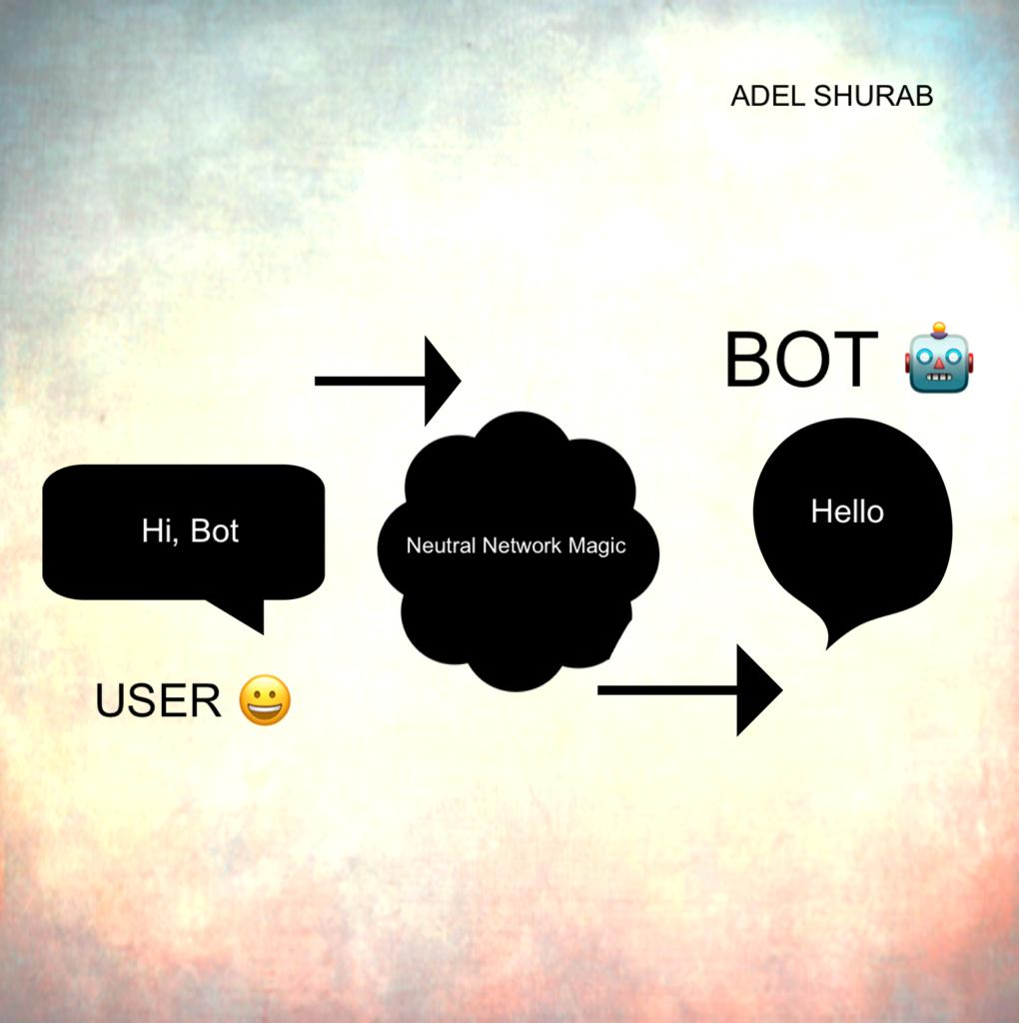
Figure 2 this image was made for illustration
Why and When Should Universities Use chat bots?
Secure more course registrations with chat bots: Understanding what makes your target audience unique is crucial to understanding how chat bots can benefit universities and colleges. Students worry a lot at every point of their academic life. They make critical choices in their lives, choices that will shape their future. They want to make sure that the course they end up taking is the best fit for their academic and career goals, as well as their budget and other practical considerations. They also have a large number of college websites to peruse, automated tests, course notes and more: You can create educational chat bots in many ways to improve the user experience on your school website or e-learning platform. Beta tests and tests using AI robots have already been distributed , They have proven to be great academic subjects that students can access quickly and in their spare time. Chat bots can also perform other automated functions, such as sending test scores and collecting course feedback from students, which saves time and effort for both professors and students. World online chat bots these, robots are programmed to respond to questions asked by the newest class of pupils each year. New students can find quick answers to questions like "Where's Lecture Hall 14?" and "What is my fresher approach?" They can quickly get to know campus, feel comfortable, and have a much lower likelihood of dropping out after the first few weeks. [2]
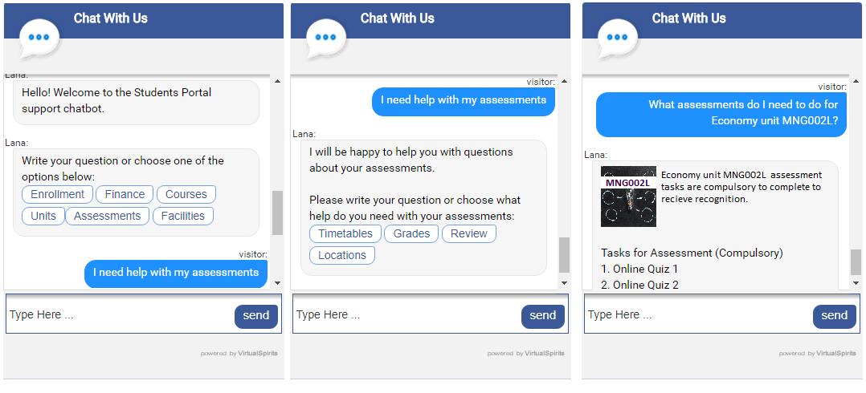
Figure 3 SIMPLE EXAMPLE [2]

Related work:

There are many bots and here I will present a number of the most famous Arabic bots:

1-Expand Bots : Expand Bots is the best Arabic chat bots in 2022, and it is one of the most powerful systems that offer a large number of features and services such as 2-The Expand Bots can respond to messages and comments automatically and quickly as soon as they are sent 3-whether each comment separately or specifying a specific comment for the chat to reply to all the comments at once, and other than the comment, it can send a private message to the customer as well4-Conducting full conversations with students, including the most important questions and frequently asked questions such as (absences, marks, etc.) 5-Collect student data such as (name, email). [3]

2. wide bots platform :The Wide bots platform is one of the most famous Arab platforms that allows creating and designing a chat bots to talk and communicate with your customers through more than one different application You can specify the content of the conversation between the bots and the client You can set the terms of transferring the conversation to one of your support team members when needed Sending periodic reports on the performance of the chat bots to track the level of performance of the bots and its development as needed The possibility of creating a bots that supports more than one language besides the Arabic language [4]

3. Botsify: Botsify is an Arabic chat bots characterized by providing many services and various features that support any online business to provide the best shopping experience for its customers Among the most important features that Botsify provides to its users:1-The possibility of merging more than one form for more than one different conversation 2-The possibility of interfering at any time during the conversation of the bots and the client and conducting the conversation yourself instead 3-The possibility of activating more than one language besides the Arabic language, according to the languages ​​supported by your online store 4-Linking the chat bots to more than one way to talk to customers in addition to the online store, such as the Messenger application, the What’s App application, and the mobile text messaging system. Provide analysis and periodic reports on the performance of the chat bots and the extent of the satisfaction of your customers with it. [5]
Research Objective :
1- to create a chat bots for ASAC to help them .
2- To solve their problems communicating with students through these chat programs
RESEARCH Methodology:
A- Qualitative and Quantitative , Mixed
Qualitative: Qualitative research is a scientific method of observation to obtain non-numerical data. This type of research refers to the meanings, concepts, definitions, characteristics, metaphors, symbols, and descriptions of things, not to their enumeration or measurement. This research answers how and the possible causes of a particular phenomenon occurring, rather than the number of times it occurs Texts, images, videos, and audio can all be used to collect qualitative data. You could be working with interview transcripts, survey responses, field notes, or recordings from natural settings, for example. [6]
Quantitative: Quantitative research refers to the systematic investigation of social phenomena through statistical, mathematical or computational methods. Quantitative research aims to develop and employ mathematical models, theories, and/or hypotheses related to phenomena. The measurement process is the focus of quantitative research because it forms an effective link between empirical observation and the mathematical expression of quantitative relations [7]
Mixed: A blended strategies research approach is an investigation method that combines and coordinates Qualitative and quantitative examination procedures in a single examination study. It entails obtaining and examining Qualitative and quantitative data in order to better understand a characteristic and answer the exploration questions. The main argument for using blended strategies research is that it capitalizes on the strengths of each information kind while eliminating their weaknesses. Analysts use Qualitative and quantitative tactics to extend their proof, improve the credibility of their discoveries, and compare the results of one strategy to the results of the other. [8]
B- Data collection: Before we define assortment, we must first answer the question, "What is data?" The condensed answer is that information is various types of data that are designed with a certain objective in mind. Thus, data gathering is the process of gathering, estimating, and breaking down precise data from a variety of significant sources in order to search out answers to examine issues, answer inquiries, analyze results, and establish trends and probability is the deliberate course of obtaining and estimating data on factors of interest to respond to determined research questions, test speculations, and assess results [9]
C-I used Quantitative Research I asked several questions to the students at the ASAC to gather the data I needed from them and to identify the problems they encountered during distance education. I asked them about the speed of the university’s response to them, and I asked them about their knowledge of the lecture dates and some questions that could help me find a solution for them through the robot that I will develop. The survey contained two Arabic versions and an English version to take into account the situation of all students and get everyone’s opinion
D- In choosing this method to get answers for my research which is the survey quantitative question, it was a positive thing because with it I was able to answer from the largest number of students in an easy, convenient and time-saving way. I chose it, and it was successful and was the best solution to get answers from students. It was very useful for me and my research because it saved a lot for me. It was easy for the students and did not take any of their time and easy for them.
RESEARCH Data:
A-The cost was free because I used free tools and it did not cost anything because everything was fully available and I did not need to spend money and I faced some problems which were the short time due to study and life matters.
B- I faced several challenges, namely finding the appropriate tool to collect data and choosing a method to ask questions to get the answers I want from the students and convey the idea to them. The expiry of the period and also Completing it. One of the challenges was also that the exams were in the month of Ramadan, and the time was very tight, and there were also the presence of the notes that I had to finish.
C- I used Google Forms to get and analyze the data and it was a convenient and easy to use tool Through these questions I was able to deduce the problems and thus I will create a chat bots that will help them solve these problems. https://forms.gle/NJpkX6sGjTdSbPgdA
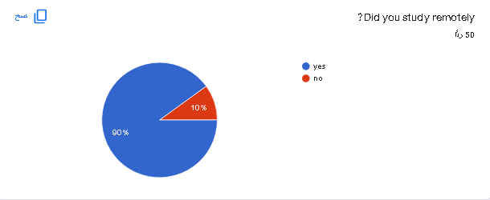
Figure 4 QUESTION 1
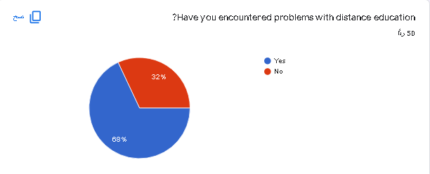
Figure 5 QUESTION 2
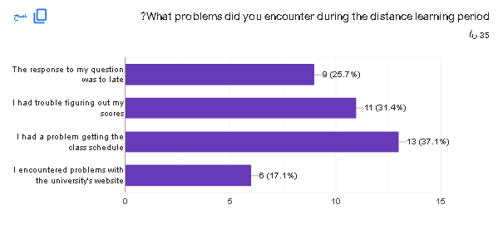
Figure 6 QUESTION 3

DISCUTION AND ANALYSIS:
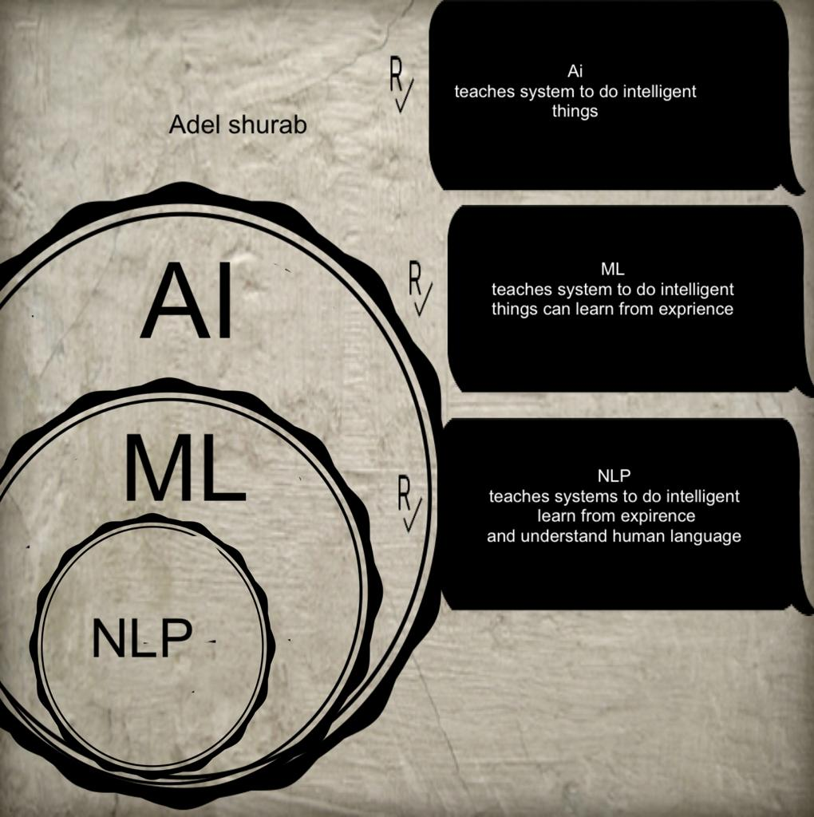
Figure 7 This image is made for illustration how AI , LM and NLP work together

Designing the training data
Designing a domain-specific contextual chat bots requires a data set to test and validate the performance of that architecture. Data properties must be versatile; Covering various topics in several depths. For these reasons, we chose to build a robot around for universities for the purpose of serving students. The reason why universities are chosen as a specific field is that - universities have a lot of multiple services that ensure the breadth of the data set. Not only that, but a typical conversation with students can go into several depths including marks, hall locations, absences, exam dates, etc. related information. This type of multi-depth conversation is necessary to test the ability of context in a framework structured this data into this following model. Tag: a unique name for each topic that the model covers Sample Patterns: Example of sample query of that topic and Possible Responses: Sample responses of the topics. After identifying the topic, one of these responses will be randomly chosen as an answer to the query Then some basic contextual elements were added and Current Context: Changes the state/context of the conversation, if needed and Related Context: Helps to filter out the result based on the context set System design We'll go over our system design strategy in this part to begin, we need domain-specific data in order to train the chat bot. The data is pre-labeled and each chapter includes some sample cases and other information to help follow the conversation's progress. As a result, when a user submits a new query, we must associate it with one of our pre-existing classes based on the sample currently present in each class. We provide the user with the right answers to his questions based on the topic selected. [10]

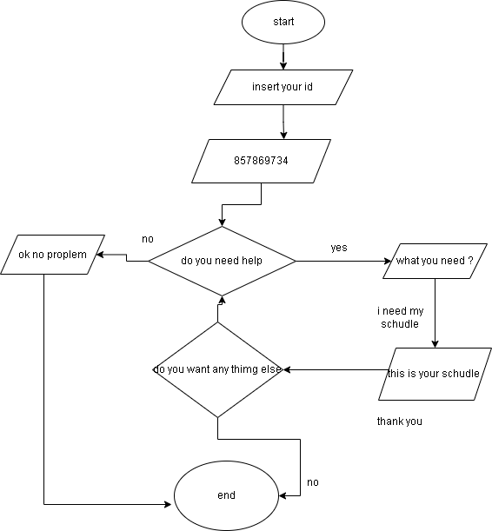
Here, I explain in a very simple way how the chat bots works, as it fetches information from the data base that we have built for it, where it answers through an if statement and this Flowchart explains
Figure 8 Flowchart FOR CHAT BOT
CONCLUSIONS AND FUTURE WORK:
Ultimately, this project aims to create chat bots for ASAC to make it easier for students to get whatever they want without waiting. These bots can guide them to their hall locations in case they are new students and enable them to get to know all parts of the campus without getting lost, the names and grades of their teachers, bus departure times and also when they are at home they can know everything as if they were at the university. I mean, we can say that he is their teacher, their companion who answers their questions no matter what, as he helped the university solve the problems they face and also saved the university staff and provided assistance to the largest possible number of students. I will present my project idea to ASAC through a trial version for their use, and I will give them a trial version to evaluate the service of this robot With their students and explaining how it works by explaining to them about its goals and objectives and explaining its parts and functions and giving them an overview of the design and how it was worked on and also the first goal of this project is to create chat bots for ASAC to be their first assistant next to the staff and the second goal is to help them communicate with students And serving as many of them as possible, they have already been helped with their problem through these chat bots. The data to be able to achieve the objectives of the research so that the results of the objectives are the same as the output of the research through many research methods where it appears in my research how I did every step so that I have the same results that I need in the end I will convince the ASAC to provide all the statistics, papers and a complete action plan, to get A complete study of the cost of the project and how it will achieve useful results, to save amounts, and to obtain a copy of it. I will also be ready to answer any question they may ask the ASAC, understand what I am doing and focus the light fully on what is exceptional in my project and show them the strengths of the program and explain to them all parts of the program and its importance By presenting their problems and providing solutions to them through the program and showing them data showing the extent of that. help them and save them from fatigue and money too, where instead of hiring call center staff and paying them, it can save them.

Works Cited

[1] | E.Porter. (2022, Mar.) How Does A Chatbot Work? [Online]. https://www.drift.com/learn/chatbot/how-does-a-chatbot-work/
[2] | University Chatbot - When And Why Should Universities Use Chat Bots? [Online]. https://www.virtualspirits.com/university-chatbot-when-should-universities-use-bots.aspx
[3] | Expandbot. (2021, Dec.) أقوى ماسنجر بوت عربي بشراكة حصرية مع فيسبوك. [Online]. https://expandbot.com/
[4] | WideBot. (2021, Mar.) المنصة المتكاملة | وايدبوت - المنصة الرائدة لبناء شات بوت تفاعلي باللغة العربية. [Online]. https://widebot.net/platform/?lang=ar
[5] | B. Botsify - Botsify Chatbot Features & Functionalitues. [Online]. https://botsify.com/features
[6] | L.Persohn, "Curation as methodology," Qualitative Research, vol. 21, no. 1, pp. 20-41, 2020.
[7] | R.Streefkerk. (2022, Feb.) Qualitative vs. quantitative research. [Online]. https://www.scribbr.com/methodology/qualitative-quantitative-research/
[8] | L.H. (2022, Apr.) What is Mixed Methods Research? [Online]. https://delvetool.com/blog/mixedmethods
[9] | (2022, May) What Is Data Collection: Methods, Types, Tools, and Techniques. [Online]. https://www.simplilearn.com/what-is-data-collection-article
[10] | A.Paul, "Focused domain contextual AI chatbot framework for resource poor languages," Journal of Information and Telecommunication, vol. 3, no. 2, pp. 248-269.

APPINDEX 1 (REFLCTION)
a- I think that my project has solved the problem that I created because of it and has played its role to the fullest because it has previously had a big role in solving such problems in other places, and here it is solving the same problem for the college and helps answer all the dogs at any time they wanted
b-I chose to do the survey and it was a successful choice because it is the most appropriate and easiest way to reach the largest number of students except that it saves effort and time on both sides, but I had to do an interview with one of the officials in ASAC to ask some of it and to have a broader idea of what the officials and students want
c-I advise the person who wants to benefit from this research to work on a new survey that has more requirements and also you must have enough information and add it to this research to complete and also make a new flowchart other than this

Plagiarism
Plagiarism is a particular form of cheating. Plagiarism must be avoided at all costs and students who break the rules, however innocently, may be penalised. It is your responsibility to ensure that you understand correct referencing practices. As a university level student, you are expected to use appropriate references throughout and keep carefully detailed notes of all your sources of materials for material you have used in your work, including any material downloaded from the Internet. Please consult the relevant unit lecturer or your course tutor if you need any further advice.
Student Declaration
Student declaration
I certify that the assignment submission is entirely my own work and I fully understand the consequences of plagiarism. I understand that making a false declaration is a form of malpractice.

Student signature: Date:

